First run: Hash ./testdir and ./testdir/test.txt

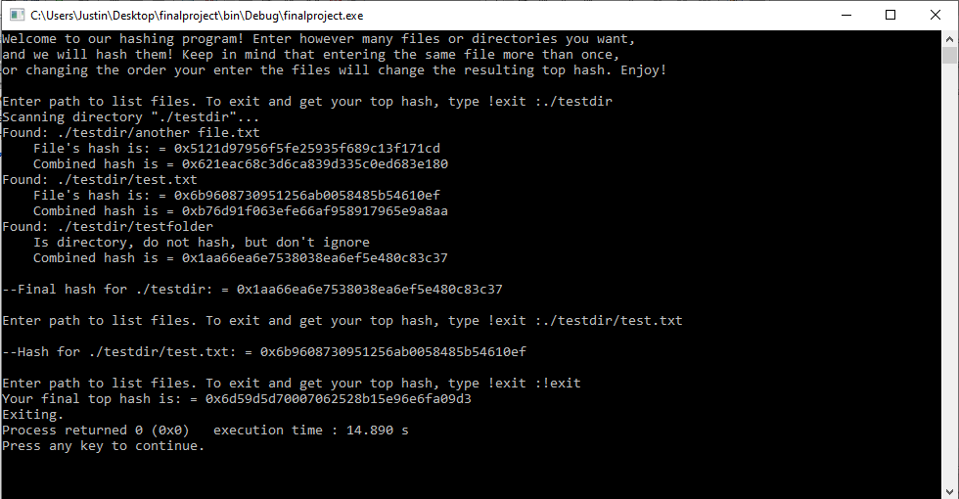

Second run: Hash ./testdir and ./testdir/test.txt again (Should get same hash)

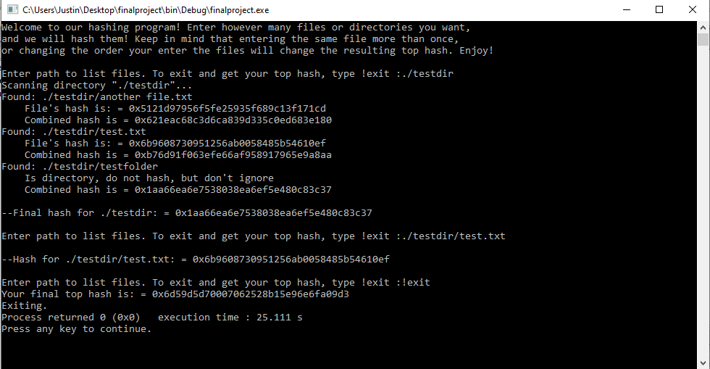

Third run: Hash ./testdir and ./testdir/test.txt, but change test.txt inside the text file

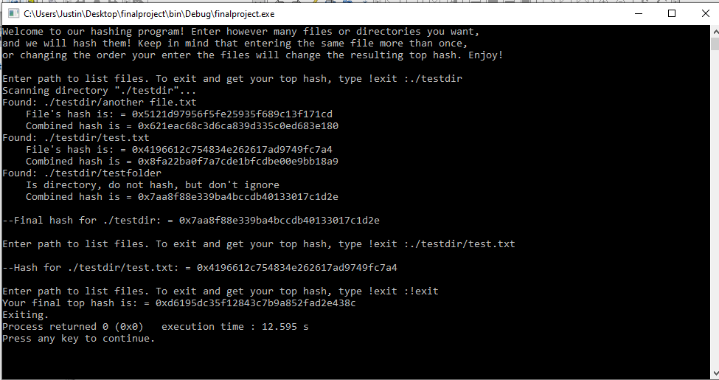

Fourth run: Hash ./testdir and ./testdir/test.txt, but delete another file.txt from ./testdir

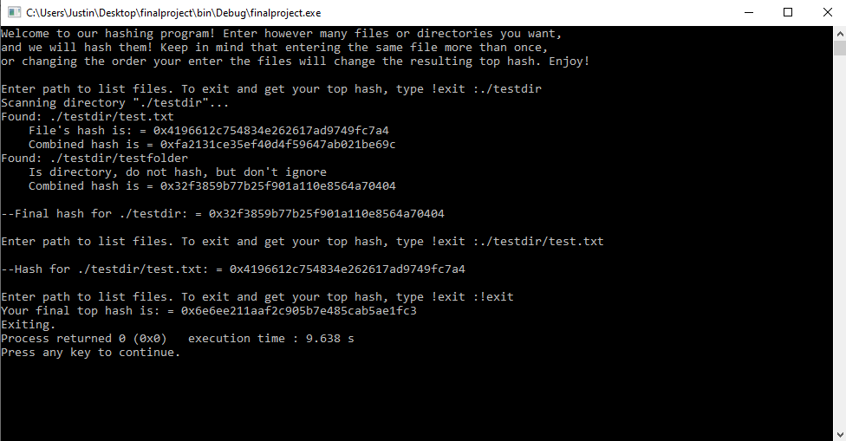

Fifth run: Hash 3 different files, and also use absolute address rather than relative

C:\Users\Justin\Desktop\finalproject\testdir/test.txt, C:\Users\Justin\Desktop\finalproject\testdir/testdir/testfolder/1test.txt, and C:\Users\Justin\Desktop\finalproject\testdir/testdir/testfolder/2test.txt

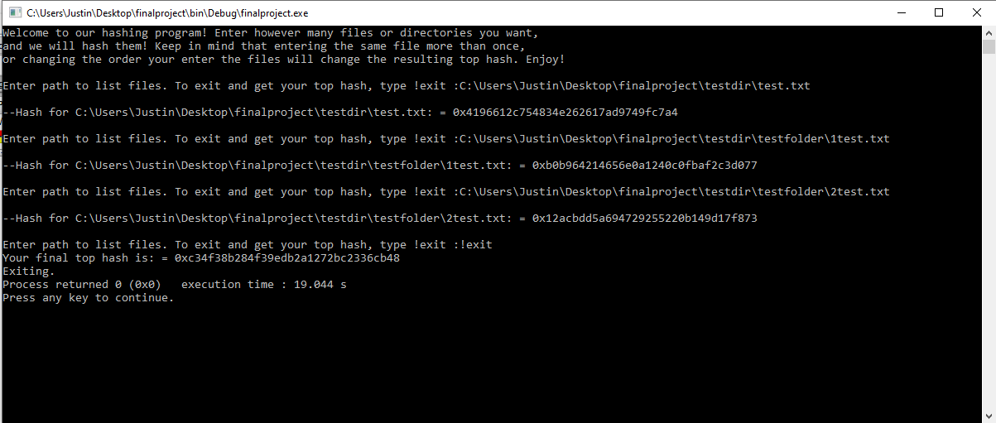

Sixth run: Do the fifth run once more to show it works

